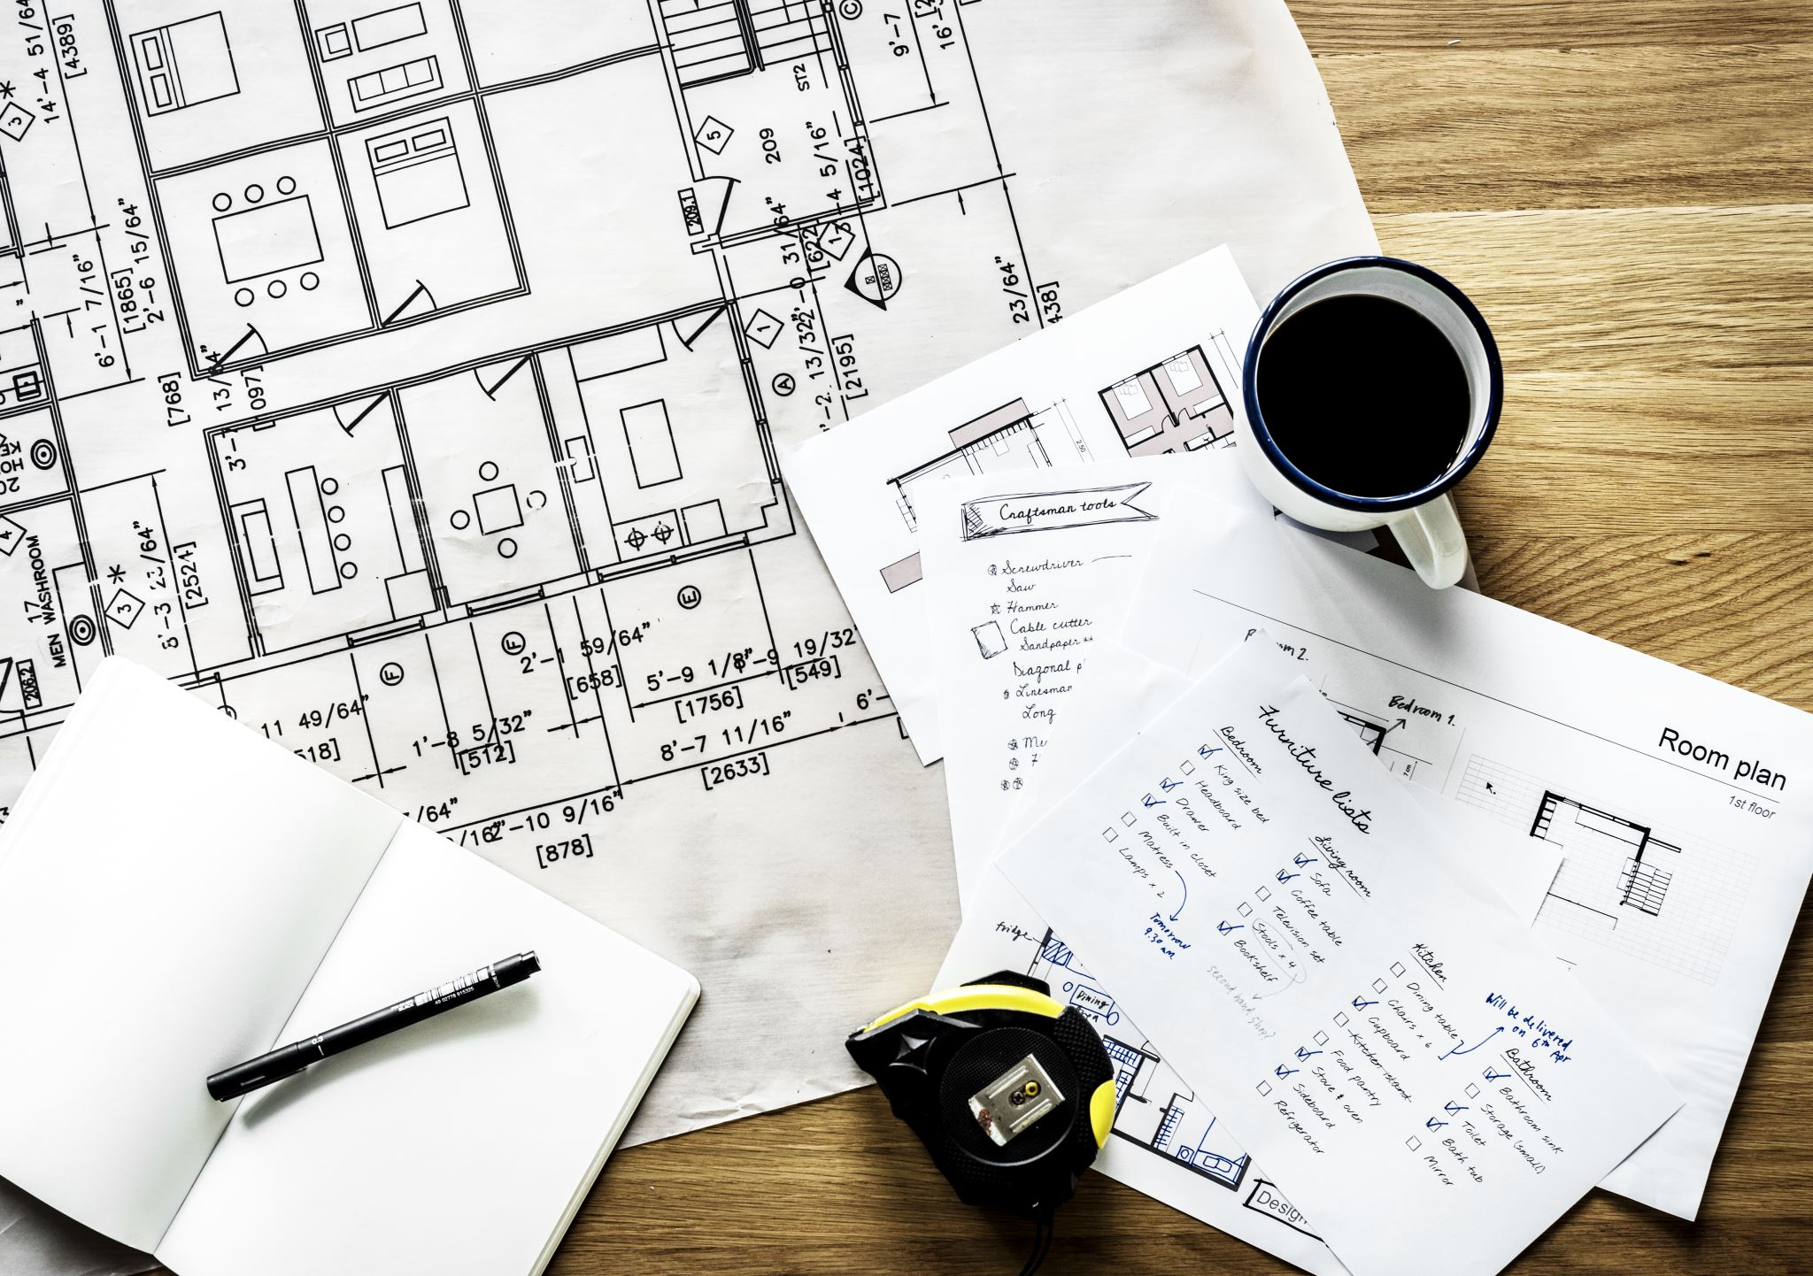

Project Proposal Template

## Course: ELTC H3024 Project Part 2

## Supervisor: Ivan Smyth

## Project Title: Remote machine monitoring and tracking device

## **1.** Project Description

* Companies have big issues with machinery mistreatment, abuse and breakdowns.

This project aims to provide owners with the ability to track and log the information of their owned machinery.

* The target audience would be business owners that employ machinery, machine manufacturers.
* I plan to employ a variety of sensors such as temperature sensors, pressure level sensors, speed sensor impact sensor and more, additionally i plan to use the ESP-32 as my main controller, along with some form of communication protocols such as, loRA, NB-IoT, wifi or bluetooth.

I also am thinking to employ an app to provide the user a place to keep track of all their owned machines and their data

## **2.** System Architecture

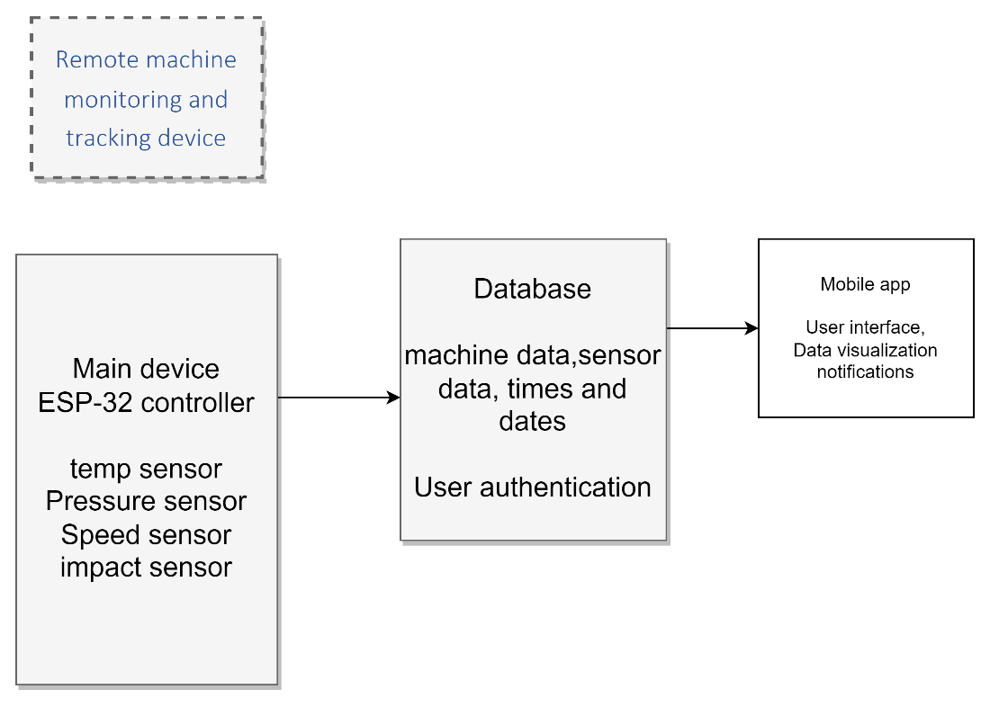

The esp controller controls all the sensor data and sends it up to the cloud database, which then the mobile app pulls data from it to inform the user.

## **3.** Project Scope

* Presentations, project demo, video, report, weekly journal, mobile app.
* My project will include the main device along with all the sensor capabilities and the app.
* Things excluded from the project will be the multiple communication forms, it will mainly provide 1.

The main challenge in this project will be developing the database, and mobile communication,

And data transmission of the device to other systems.

## **4.** Project Schedule

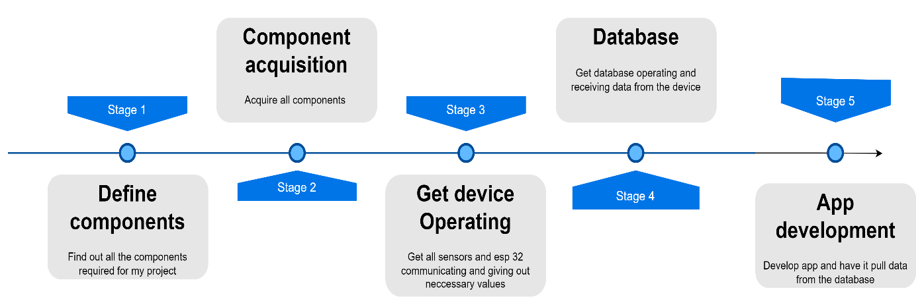

## **5.** Resources Required

* RS PRO Temperature Probe 124-1080: €13.54
* SEEED STUDIO 109020022 (Farnell ireland) : €12.70
* ADAFRUIT INDUSTRIES 3-Axis Sensor, Module, I2C, 16-Pin (RS radionics): €6.27
* MiniSense 100 Vibration Sensor (farnell ireland) : €6.01

(Not completed )

## **6.** Expected Outcomes

* The intended impact of this device will reduce the costs on sites for repairing or replacing damaged machinery, which will also reduce the need to produce more parts for the machines, which will thus reduce carbon emissions.
* This project will provide an easy and mobile solution to machine tracking and logging.
* The project's success will be weighed by how well it can track the info of the machine and to what percentage failure rate. Additionally, a metric will be the response time of the database to phone, if a machine has suffered engine overheating or a big impact how fast will that info be provided to the owner.

## **7.** Ethical/ Safety Considerations

* Ensure sensors and devices meet safety standards to prevent accidents.
* Implement fail-safes to shut down machinery in case of sensor malfunction.
* Regular maintenance checks on sensors and devices.
* Data Privacy: Implement encryption for data transmission and storage.
* Security: Regularly update firmware and software to patch vulnerabilities.
* Environmental Impact: Choose eco-friendly materials and disposal methods for hardware.

## **8.** Conclusion

The project aims to address machinery mistreatment, abuse, and breakdown issues by providing a comprehensive tracking and logging solution for business owners and machine manufacturers. The system involves the use of sensors, an ESP-32 controller, a central database, and a mobile app to enable real-time monitoring of machinery conditions.

Value Proposition:

Efficient Tracking: Employing a variety of sensors for detailed monitoring.

User-Friendly Interface: A mobile app for easy access to machine data.

Reduced Costs: Minimizing repair and replacement expenses, thereby reducing carbon emissions.

Expected Outcomes:

Cost Reduction: Less need for repairs and replacements.

Environmental Impact: Reduced carbon emissions through optimized machinery usage.

User Convenience: Quick and easy access to machine information via the mobile app.

Commitment and Enthusiasm:

* Recognizing the challenges, especially in database development and mobile communication, we are dedicated to overcoming them.
* We believe in the positive impact this solution can have on businesses and the environment.

## Appendix:

* Include any additional information, diagrams, or data relevant to your project proposal.